NEXTGEN ECONOMICS
WHITE PAPER · SOVEREIGN DEBT & GLOBAL FINANCIAL ARCHITECTURE
A Rules-Based Framework for Sovereign Debt Stability
Building a Just and Equitable Global Financial Architecture
An independent framework for resolving sovereign debt crises — drawing on the Brady Plan precedent, the IMF and UNCITRAL institutional architecture, the Accounting View of Money, Ray Dalio's long-term debt cycle theory, and intercreditor equity and human-rights-aligned reform principles — proposing a rules-based, pragmatic path from creditor fragmentation and G20 Common Framework failure toward predictable, equitable restructuring.
Pawan Bhatia
NextGen Economics · Bangalore, India
Sixth Draft · 2026
Compiled with the assistance of AI tools for data synthesis and drafting, and rigorously reviewed and verified by human subject matter experts.

Table of Contents

Executive Summary 3
Framework at a Glance 3
Guiding Principles of Sovereign Debt Stability 4
Part I — The Problem: A Fragmented, Failing System 5
Part II — Foundational Concepts and Methodological Framework 8
Part III — Equity, Inequality, and the Japanese Exception 10
Part IV — Stakeholder Incentives: The Reform-for-Stability Bargain 12
Part V — The “Money Stuck” Problem and Its Resolution 14
Part VI — Innovative Debt Solutions: From Burden to Asset 15
Part VII — Success Metrics 16
Part VIII — Digital Finance and Implementation 17
Part IX — Stress-Testing the Framework 18
Part X — A Sovereign Debt Stability Treaty 19
Part XI — Risks and Consequences of Inaction 20
Part XII — Implementation Roadmap 21
Part XIII — Conclusion: A Vision for the Future 22
References 23

Executive Summary
This white paper proposes a fundamental restructuring of the sovereign debt resolution architecture. The current system is failing — trapping nations in cycles of unsustainable debt, deepening inequality, and perpetuating a global financial order where nearly half the world's population lives in countries where debt service exceeds spending on health or education.
The paper argues that meaningful reform is only possible if it serves the self-interest of major financial players while embedding equity and human rights at its core. Drawing on historical precedent (the Brady Plan), contemporary institutional frameworks (IMF, UNCITRAL), conceptual innovations (Accounting View of Money, Ray Dalio's cycle theory), and legal principles (intercreditor equity, human rights-aligned reforms), we outline a pragmatic, rules-based framework for resolving sovereign debt crises.
The Bottom Line: The alternative to reform is not a better system — it is the self-reinforcing downward contraction that Dalio warned of. The question is not whether to reform, but whether to do so in a controlled, rules-based manner or to wait for the inevitable crisis that will force action under far worse conditions.
“Our world may be wealthier today than when the current international financial architecture was established, but it is also more fragile.”
— Kristalina Georgieva, IMF Managing Director, G20 Finance Ministers statement, July 2023

Framework at a Glance
Problem | Current System | Proposed Solution | Expected Outcome
Fragmented creditors | Years of delay; paralysis | Single creditor committee; UNCITRAL Model Law | Faster restructuring; 12–18 months
Debt sustainability | GDP ratios; opaque | CCA methodology + Human Rights DSA | Better risk measurement; protected social spending
Holdouts | Litigation; uncertainty | UNCITRAL supermajority voting + legislative caps | Higher participation; 80% reduction in litigation
Frozen capital | Market paralysis; money stuck | Brady-style bonds with collateralization | Capital flows resume; market access restored
Austerity | Social collapse; protests | Protected health (5% GDP min) + education (4% GDP min) | Political stability; human dignity preserved
Intercreditor equity | Unequal burden; informal creditors bear costs | Comparable treatment formula; informal creditor participation | Fair burden-sharing; sustainable outcomes
Inequality | Deepening poverty; rights violations | Human rights-aligned reforms; UN-hosted mechanism | Equity-centered outcomes; SDG alignment

Guiding Principles of Sovereign Debt Stability
A successful sovereign restructuring framework should satisfy seven core principles:
1. Predictability: Clear rules and timelines replace ad-hoc negotiations; countries and creditors know what to expect.
2. Transparency: All negotiations, debt data, and restructuring terms are publicly available; creditor participation is visible.
3. Comparable Treatment: All similarly situated creditors bear a comparable burden; no free-riders or preferential treatment.
4. Human Dignity: Restructurings protect minimum essential levels of economic, social, and cultural rights. This is a binding constraint on the restructuring math, not an aspiration: creditor recovery is calculated on what remains after the health (5% GDP) and education (4% GDP) floors are funded, not the other way around. Existing IMF program “social spending floors” have been criticized as non-binding in practice; this framework is explicit that it means to be different, and treats that as a testable commitment, not a rhetorical one.
5. Financial Stability: Restructurings restore market access and unlock frozen capital; systemic risk is contained.
6. Market Compatibility: The framework works with existing market structures; Brady-style bonds, LMOs, and collateralization provide market-friendly tools.
7. Shared Responsibility: All stakeholders — creditors, debtors, international institutions — share the burden of reform; the costs of crises are not borne by the most vulnerable alone.

Part I: The Problem — A Fragmented, Failing System

1.1 The Historical Timeline: Why Reform Is Necessary
1970s — Oil shocks; petrodollar recycling; reckless lending to developing nations.
1980s — Latin American Debt Crisis; the “Lost Decade”; the nine largest U.S. banks hold 176% of capital in LDC debt; Mexico's debt reaches 292% of GDP.
1990s — The Brady Plan (1989) converts defaulted loans into collateralized bonds; the HIPC Initiative (1996) provides debt relief for heavily indebted poor countries.
2000s — Argentina defaults (2001); the Greece crisis (2010); Eurozone contagion; the bank–sovereign doom loop; bailout programs break contagion.
2010s — China emerges as the largest bilateral creditor via the Belt and Road Initiative, with $472 billion committed through policy banks between 2008 and 2024; creditor fragmentation intensifies.
2020 — COVID-19 triggers a debt surge; the G20 launches the Common Framework in November 2020.
2024 — The G20 Common Framework is declared “failed”; no country has finalized a full restructuring. Zambia (3+ years), Ethiopia (5+ years), and Chad (4+ years) remain unresolved.
2025 — The G20 Summit in Johannesburg fails to advance reforms; AFRODAD concludes that “South Africa's presidency fell short of advancing global financial architecture reforms.” Debt in developing countries reaches $109 trillion.
2026 — This paper proposes a rules-based framework for sovereign debt stability.

1.2 The Historical Precedent: The 1980s “Lost Decade”
The Latin American debt crisis of the 1980s provides a stark warning. By 1982, the nine largest U.S. banks held Latin American debt amounting to 176 percent of their capital — a staggering overexposure. Mexico's debt had ballooned from 46.6% of GDP in 1960 to 292.2% by 1982, driven by oil-financed infrastructure projects.
The resolution required a decade of negotiations and multiple restructuring attempts. The Brady Plan of 1989 finally broke the logjam by offering a clear, mutually beneficial solution:
- Creation of “Brady Bonds”: Converted defaulted bank loans into new, tradable bonds.
- Collateralization: Principal secured by U.S. Treasury zero-coupon bonds, making new bonds performing assets.
- Creditor Choice: A “menu” of options — Par Bonds (face value with low interest) or Discount Bonds (haircut with market interest).
The Brady Plan worked because it gave commercial banks a way to remove nonperforming loans from balance sheets and replace them with performing, collateralized bonds. This is the core of the “reform-for-stability” bargain.
A Caveat on Scale: The Brady precedent should inform this framework, not be mistaken for a template that scales automatically. Brady bonds totaled roughly $160 billion in face value across about seventeen countries, overwhelmingly Latin American bank loans owed to a relatively concentrated set of commercial creditors. Today's comparable restructuring need is estimated at roughly $812 billion across a far more fragmented creditor base — bondholders, China's policy banks, and private capital markets that barely existed in their current form in 1989. A 2023 IMF working paper assessing the Brady Plan's own legacy concludes plainly that Brady-style solutions “alone would not address current challenges.” This framework borrows the Brady Plan's logic — collateralized, official-sector-backed instruments that convert non-performing claims into performing ones — without assuming its 1989 mechanics transfer at 2026 scale.
“Our objective is to rekindle the hope of the people and leaders of debtor nations that their sacrifices will lead to greater prosperity in the present and the prospect of a future unclouded by the burden of debt.”
— Nicholas Brady, U.S. Treasury Secretary, announcing the Brady Plan, March 1989
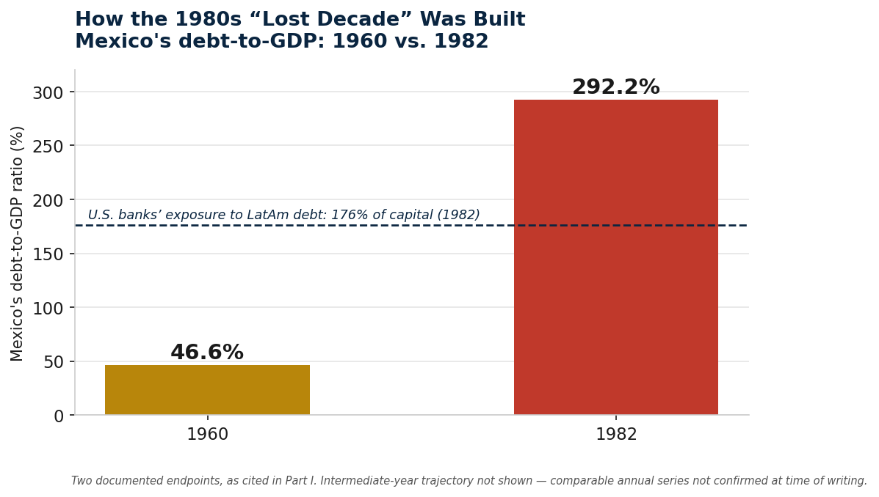
Figure 1. Mexico's debt-to-GDP ratio, 1960 vs. 1982 — the two documented endpoints behind the “Lost Decade.”

1.3 Contemporary Evidence: The Human Cost
Today, 3.3 billion people live in countries where debt service exceeds spending on education or healthcare. The evidence is devastating:
Country | Debt Service vs. Budget | Human Cost
Dominican Republic | 31% of budget to debt; 228% more than healthcare | Pregnant Haitian women avoid prenatal care due to immigration enforcement
Malawi | 25.4% of revenue to debt; 5.7% to health | 87% of teachers lack basic resources; 200 pupils per classroom
Kenya | 54% of budget to debt; 2.4x health+education combined | Gen Z protests against taxes on bread, cooking oil, sanitary pads — dozens killed
South Sudan | 27% of budget to debt | 70% of children out of school; over 50% of teachers untrained

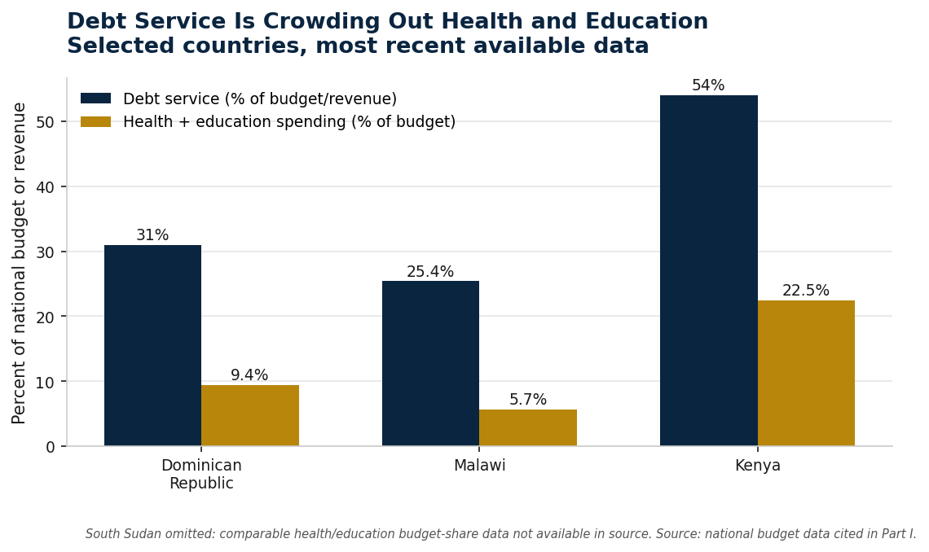
Figure 2. Debt service versus combined health and education spending, selected countries. South Sudan omitted — comparable budget-share data not available.
“3.3 billion people is more than a systemic risk. It is a systemic failure.”
— António Guterres, UN Secretary-General, at the launch of “A World of Debt,” September 2025
As the UN Independent Expert on foreign debt and human rights, Attiya Waris, stated: “Failures in global tax governance, escalating sovereign debt burdens, and unchecked illicit financial flows are eroding States' ability to uphold minimum essential levels of economic, social, and cultural rights.”

1.4 The Inequality Dimension: Who Bears the Cost?
The costs of sovereign debt crises are unequally distributed within debtor states. A UNU-WIDER analysis reveals:
- Domestic elites who have access to global financial markets can mitigate the costs of default, while ordinary citizens cannot.
- Informal creditors — pensioners who have contributed to state social security funds, workers who have paid into public insurance systems, citizens relying on government services — bear the worst of austerity through cuts to social security, health, and education.
- “Premature capital account liberalization” — relaxing capital controls — “can have the perverse effect of increasing the probability of default.”

1.5 The Creditor Fragmentation Crisis
The creditor landscape is more fragmented than ever — Paris Club members, non-Paris Club creditors (especially China), private bondholders, and regional banks with hybrid mandates.
Zambia: Defaulted in October 2020. It took over three years for China to provide financing assurances required for IMF lending. Agreements include asymmetric mechanisms that increase debt service when conditions improve but provide no relief during downturns.
The Afreximbank Conflict: Zambia and Ghana have relegated Afreximbank — an African multilateral development bank — from preferred creditor to commercial lender status. This is a dangerous precedent. If African MDBs lose preferred creditor status, funding costs will rise, and African countries will lose a critical lifeline for trade finance and crisis response.

1.6 The G20 Common Framework Collapse
The G20 Common Framework, launched in 2020, has failed utterly. No country that applied has finalized a full restructuring:
Country | Wait Time | Status
Ethiopia | 5+ years | Still unresolved; private creditors rejected terms
Zambia | 3+ years | ~94% complete but not closed
Chad | 4+ years | Received no debt relief — only rescheduling
Ghana | 2+ years | Unresolved

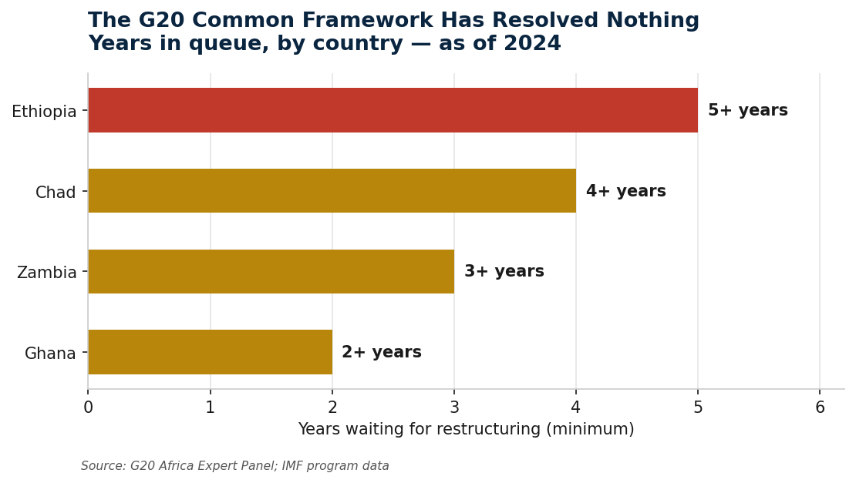
Figure 3. Years in the Common Framework queue, by country, as of 2024. None has completed a full restructuring.
“Everything takes much longer than countries need and expect.”
— Kristalina Georgieva, IMF Managing Director, Reuters interview, February 2024
Common Framework restructurings have reduced only about 7% of the combined external debt stock of high-risk lower-income countries — roughly $13.6 billion out of $171–184 billion. The South African G20 Africa Expert Panel, chaired by Trevor Manuel, called the Common Framework “inefficient and ad hoc” — making debt restructuring “highly politicised and slow.” Their conclusion: “The current system is failed.”

Part II: Foundational Concepts and Methodological Framework

2.1 Ray Dalio's Long-Term Debt Cycle Theory
Ray Dalio's Principles for Dealing With the Changing World Order provides a crucial diagnostic framework: economies move through long-term debt cycles lasting 50 to 75 years. Because these crises “happen only once in a lifetime, most people don't expect them. As a result they typically take people by surprise and do a lot of harm.”
Core Mechanism: “Since one entity's spending is another's income, when one entity cuts its expenses, that will hurt not just that entity, but it will also hurt others who depend on that spending to earn income. Similarly, since one entity's debts are another's assets, an entity that defaults reduces other entities' assets, which requires them to cut their spending. This dynamic produces a self-reinforcing downward debt and economic contraction.”
Key Insight: “Most money and credit (especially the government-issued money that now exists) have no intrinsic value. They are just journal entries in an accounting system that can easily be changed. The purpose of that system is to help allocate resources efficiently so that productivity can grow, rewarding both lenders and borrowers, but the system periodically breaks down.”
Political Constraint: Dalio explicitly identifies the deepest obstacle: “Politics stands in the way. I went down to Washington, spoke to leaders of both parties, and they agree that this is — we have to get the deficit down 3% of GDP or whatever. But they tell me that they can't because of politics.”

2.2 The Accounting View of Money (AVM)
A foundational conceptual error underpins current sovereign debt management: central bank money is accounted for as debt. The Accounting View of Money (AVM) corrects this error.
The Liability Illusion: A financial liability is “a contractual obligation of one entity to transfer an economic resource to another.” But central bank reserves do not satisfy this definition:
- Reserves are created when the central bank credits an account — they are not resources placed with the central bank as a loan.
- Reserves are irredeemable — unlike conventional debt, they cannot be converted into gold, foreign exchange, or any superior monetary instrument.
Why the Liability Classification Persists: “The answer is not analytical necessity but historical inertia. Under metallic and convertible monetary systems, central bank money was indeed redeemable into specie or foreign assets. But once convertibility disappeared and sovereign fiat systems became the norm, the old form survived even though its conceptual foundation had vanished. Accounting language outlived the monetary regime that had once justified it.”
The AVM Reform: Under AVM, money issuance — whether reserves, banknotes, or CBDC — would be recorded not as a liability but as equity, reflecting the state's sovereign power to create monetary value.
Why This Matters: The current liability convention “is often dismissed as harmless bookkeeping. It is not. Accounting categories shape institutional understanding. They influence legislation, policy debate, and public interpretation.”
A Scope Limitation, Stated Plainly: AVM reclassifies a central bank's own money issuance — its domestic-currency reserves, banknotes, and CBDC. It does not, by itself, resolve the external, foreign-currency debt at the center of every case study in this paper: Zambia, Chad, Ghana, and Ethiopia owe dollars to outside creditors, not domestic-currency liabilities to their own banking systems. Relabeling a central bank's balance sheet does not change what it owes abroad. AVM's relevance to this framework is narrower and indirect: it may strengthen the institutional credibility of a restructuring central bank, and it may inform how CBDC-era debt instruments are eventually classified. It is not, and is not presented here as, a mechanism for resolving the external debt crises this paper otherwise addresses.

2.3 The IMF's Institutional Framework
The IMF's 2024 Guidance Note on Financing Assurances and Sovereign Arrears Policies provides the operational architecture:
Financing Assurances Policy: Fund-supported programs must be “fully financed” — no balance-of-payments financing gaps.
Debt Sustainability Requirement: “Lending into an unsustainable public debt situation would by definition fail to restore the member to medium-term external viability.”
Lending-into-Arrears Policy: Under certain conditions, “the Fund can lend into arrears.”

2.4 The UNCITRAL Model Law Approach
The UNCITRAL Model Law on Sovereign Debt Restructuring provides a legal blueprint. Key features:
Feature | Provision
Purpose | Reduce social costs of sovereign debt crises, systemic risk, creditor uncertainty
Scope | Applies where the law of a jurisdiction governs the debtor-creditor relationship
Supervisory Authority | Neutral international organization administers process — not designed by the IMF, nor is the IMF part of its supervisory process
Voting | Plan binding when approved by creditors holding at least two-thirds in amount and more than one-half in number
Recognition | Jurisdictions enacting the Model Law recognize and enforce each other's restructuring decisions
Retroactivity | Optional retroactivity: “would provide significant social benefit and little harm”

2.5 Risk-Based Debt Sustainability Framework (CCA)
The IMF's Contingent Claims Analysis (CCA) provides a more robust framework:
Traditional DSA | CCA-Based Risk DSA
Focuses on debt-to-GDP ratio | Incorporates balance sheet structure and uncertainty
Does not capture uncertainty | Explicitly incorporates uncertainty and volatility
Invariant to volatility | Distance to distress falls with increased volatility
Does not assess maturity risk | Distress barrier includes maturity/rollover risk

The Distress Barrier Defined: “The sum of the present value of principal payments, discounted at the risk-free rate, and the present value of interest payments up to maturity.”

Part III: Equity, Inequality, and the Japanese Exception

3.1 The Equity Imperative: Redistributing the Burden
At its core, the sovereign debt crisis is a crisis of inequality. The current restructuring framework perpetuates power imbalances between the Global North and Global South. “Restructurings have often failed to achieve equitable outcomes, perpetuating cycles of unsustainable debt.”
Intercreditor equity is the legal principle that all similarly situated creditors should bear a comparable burden. As the World Bank's Chief Economist notes: “Whatever is disproportionately good for any one creditor or group of creditors will probably be disproportionately bad for all the others.”
Human rights-aligned reforms demand:
- Integrate human rights impact assessments into debt sustainability analysis.
- Guarantee minimum levels of public investment in health, education, and social protection.
- Require inclusive, participatory restructuring processes.
- Shift decision-making power from creditors to multilateral, rights-based institutions.

3.2 Japan's Debt Puzzle: A Unique Exception
Japan's government debt exceeds 200% of GDP — yet no major debt crisis has emerged. Why?
- Japan operates a de facto sovereign wealth fund from borrowed money, earning 6% of GDP per annum above funding costs.
- Over 90% of JGBs are held domestically — insulating Japan from external shocks.
- Net public liabilities are only 78% of GDP (gross liabilities offset by 192% of GDP in assets).

3.3 Why Japan Cannot Be a Model for Others
Factor | Japan's Advantage | Why Others Cannot Replicate
Domestic Savings | World's largest domestic savings pool | Developing nations lack deep domestic capital markets
Central Bank Ownership | BoJ holds >50% JGBs | EM central banks cannot monetize debt without sparking inflation
Currency Sovereignty | Debt is 100% yen-denominated | EM debt is often USD-denominated
Government Investment Returns | Earns 6% GDP/year above funding costs | Most governments are net debtors, not investors
Interest Rate Vulnerability | Normalizing; each 1% rate rise adds ¥2 trillion | EM nations already pay double-digit yields

The Inevitable Reckoning: Japan's “safety net” is unraveling. Interest payments already consume 16.5% of the budget. The IMF warns that by 2036, interest costs could reach 13% of total government outlays. Japan's model cannot be replicated.

Part IV: Stakeholder Incentives — The “Reform-for-Stability” Bargain

4.1 What Each Player Gains and Concedes
Stakeholder | Gains | Concession
IMF | Preserves global stability; avoids bailouts; protects lending capacity | Lending-into-arrears policy; larger role; conditionality
World Bank & MDBs | Protects AAA ratings; preserves preferred creditor status | Provides guarantees; co-designs restructuring envelope
Commercial Banks | Removes nonperforming debt; gets performing, collateralized assets | Accepts haircut; participates in Brady-style menu
Chinese Creditors | Faster repayment; risk reduction; return generation | Comparable treatment; socialization into multilateral regime
Debtor Country | Lower debt service; restored market access; fiscal space | Governance reforms; fiscal adjustment; transparency
Citizens (Informal Creditors) | Protected social spending; restored public services | Governance reforms; accountability; participation

4.2 The Five-Step Process

Step 1: Diagnosis
- Enhanced DSA using CCA methodology + Human Rights Impact Assessment.
- Distress barrier calculated to determine restructuring need.

Step 2: Formation of a Creditor Committee
- Single committee including all major creditor groups from the outset.
- UNCITRAL Model Law provides the legal framework for creditor recognition.

Step 3: Comparable Treatment Formula
- All creditors must provide a “commensurate” reduction based on NPV.
- Prevents free-riders.
This step is described here as a formula, but it should not be mistaken for a technical problem with a technical solution. Section 1.5 of this paper documents that comparable treatment — specifically, disagreement over NPV discount-rate methodology and how to treat collateralized versus commercial claims — was the central reason Zambia's financing assurances took over three years to secure. The formula does not resolve that dispute; it names it. What actually secures agreement is Step 5's official-sector backing and Step 2's single-committee structure removing creditors' ability to negotiate sequentially against each other. Comparable treatment should be understood as the framework's most politically contested element, not its most technical one.

Step 4: Brady-Style “Menu” of Options
- Option A (Par Bonds): Equal face value, below-market interest.
- Option B (Discount Bonds): 30–50% haircut, market-based interest.
- Option C (New Money): New funding with seniority.

Step 5: Big Player Guarantee
- IMF and MDBs provide official sector backing.
- Transforms risky claims into performing, tradable assets.

4.3 The “Sticks” for Holdouts
Stick | Mechanism
IMF Lending-into-Arrears | Fund can lend even with arrears
UNCITRAL Supermajority Voting | 2/3 amount + >1/2 number binds holdouts
Legislative Capping | New York and UK legislation cap judicial recoveries
Comparable Treatment Rules | No free-riders
Regulatory Pressure | New York and London regulators can pressure creditors

Part V: The “Money Stuck” Problem and Its Resolution

5.1 The Mechanism of Capital Freeze
When sovereigns face distress, corporate capital becomes trapped. The Malaysia case: sovereign uncertainty caused Petronas's dollar bond spreads to surge 53 basis points — investors had “no other bonds to express that view.” Brazil: Braskem bonds fell to 37 cents, Ambipar to 33 cents. Healthy companies refinance under stressed conditions.

5.2 Why This Framework Unlocks Capital
- Commercial banks get performing assets, investors regain pricing clarity.
- Breaks Dalio's “self-reinforcing downward debt and economic contraction.”
- Institutional backstop breaks the cycle of fear and capital freeze.

Part VI: Innovative Debt Solutions — From Burden to Asset

6.1 Debt-for-Nature Swaps
Country | Year | Deal Structure | Result
Belize | 2021 | $553M repurchase at 45% discount | ~$180M over 20 years for ocean protection
Ecuador | 2023 | Bought back $1.6B debt | $500M for Galápagos conservation
Seychelles | 2016 | Debt restructured for marine commitment | Endowment fund for Aldabra Atoll

6.2 Debt-for-Development Platforms (DDPs)
Egypt as Model: Egypt is collaborating with development agencies to turn $500 million of sovereign commitments into a Green Infrastructure Fund. By 2028, borrowing costs are expected to decline “because markets view its liabilities as structured, productive assets.”

6.3 World Heritage Bonds
The World Heritage Convention has 196 States Parties — one of the most universally ratified treaties. All but 26 countries host World Heritage sites. Financing needs are inherently actionable.

Part VII: Success Metrics
Metric | Target | Measurement
Average restructuring time | <12 months | From trigger to implementation
Litigation cases | -80% from current | Lawsuits filed against debtor nations
Market re-entry | <18 months | Time to issue new bonds after restructuring
Health spending | Minimum 5% of GDP | Budget allocation to healthcare
Education spending | Minimum 4% of GDP | Budget allocation to education
Debt sustainability | Debt service <15% of revenue | Ratio of debt payments to government revenue
Participation rate | >90% of creditors | Creditor acceptance of restructuring terms
Holdout litigation | <10% of cases | Lawsuits against restructured debt

Part VIII: Digital Finance and Implementation

8.1 What Digital Tools Can and Cannot Fix
This framework's binding constraint is political — creditor coordination, comparable-treatment disputes, and the will to enter a single committee — not a shortage of data or computing power. Digital tools are worth naming precisely because their role is narrower than often claimed: they can make the comparable-treatment dispute in Step 3 harder to stall on procedural grounds, and little else on this list changes the outcome of a negotiation.
- A shared, real-time transparency dashboard for creditor commitments and NPV calculations would remove one specific tactic used to prolong disputes: contesting the numbers privately, sequentially, with each creditor group.
- Continuous debt sustainability monitoring can flag distress earlier, shrinking the gap between when a crisis is visible and when a country requests restructuring — relevant given Section 5's evidence that early reprofiling beats late crisis management.
- Blockchain-based verification has a narrow, genuine use in debt-for-nature and DDP monitoring (Part VI), where third-party confirmation of conservation or project milestones is the actual bottleneck. It has no comparable role in the core restructuring mechanism.

8.2 Legal Roadmap
Required reforms include:
- IMF Articles of Agreement amendments.
- New York Law incorporation of UNCITRAL Model Law.
- English Law incorporation of UNCITRAL Model Law.
- UNCITRAL Model Law adoption by key jurisdictions.
- Collective Action Clause (CAC) modernization.
- SDR collateral rules to support Brady-style bonds.
- Sovereign Debt Stability Treaty (long-term goal).

Part IX: Stress-Testing the Framework
Possible Criticisms and Responses:
Criticism | Response
“Moral hazard — countries will borrow irresponsibly.” | Framework entry requires independent DSA, governance reforms, fiscal adjustment, and transparency. Creditors also bear risk.
“Creditors will lose confidence and raise borrowing costs.” | Predictable restructuring improves pricing more than prolonged uncertainty. Research shows legislation can reduce borrowing costs.
“China won't participate.” | This is a genuine risk, not a solved problem — Section 1.5 shows China took over three years to provide financing assurances for Zambia, and that evidence should temper confidence elsewhere in this paper. Comparable treatment protects official creditors equally in principle, and China has participated in some restructurings (e.g., Sri Lanka), but the framework's honest position is that Chinese participation is a risk to be actively managed through bilateral diplomacy and the GSDR, not an outcome comparable-treatment rules can guarantee on their own.
“A UN Supervisory Authority is unworkable.” | UNCITRAL's existing rules provide the legal framework. UNCTAD already plays a “counter-IMF” role. The UN General Assembly has universal legitimacy.
“It will take too long to implement.” | The alternative — continued paralysis — is already taking 3–5+ years per country. Incremental adoption through legislative capping can begin immediately.
“This is just another bailout for irresponsible governments.” | Restructurings require governance reforms, fiscal adjustments, and transparency. Citizens are not bailed out — they get protected social spending.

Part X: A Sovereign Debt Stability Treaty

10.1 The Long-Term Vision
Eventually, the framework should evolve into an international treaty similar to:
- WTO Dispute Settlement — binding dispute resolution for trade.
- Paris Agreement — binding commitments with national contributions.
- UNCITRAL Conventions — harmonized commercial law.
- Basel Banking Standards — global financial regulation.
A Warning Built Into the First Example: The WTO Appellate Body is not only a model of binding dispute resolution — it is also a documented case of exactly the failure mode a debt treaty would need to survive. The United States blocked all new judicial appointments starting in 2016 and let the Appellate Body fall below a functioning quorum by December 2019; it has not heard an appeal since. Members now routinely “appeal into the void,” filing appeals they know cannot be heard, which prevents unfavorable rulings from ever taking legal effect. A single powerful member with an incentive to defect was able to disable binding dispute resolution simply by declining to fill seats — no treaty violation required. A Sovereign Debt Stability Treaty would sit between the same two powers, the United States (whose law governs roughly half of developing-world sovereign bonds) and China (the largest bilateral creditor), each with comparable leverage to stall enforcement without ever formally withdrawing. Any supervisory or dispute mechanism this framework proposes needs an answer to this specific failure mode, not just a citation to WTO's original design.

10.2 Treaty Elements
A future Sovereign Debt Stability Treaty would include:
1. Principles — predictability, transparency, comparable treatment, human dignity.
2. Institutions — Supervisory Authority, dispute resolution mechanism.
3. Procedures — standstill, DSA methodology, voting rules, enforcement.
4. Rights — minimum essential levels of economic, social, and cultural rights.
5. Timelines — 12-month restructuring target, 18-month market re-entry.
6. Sanctions — for non-participation or holdout behavior.

Part XI: Risks and Consequences of Inaction
Risk | Consequence if Unchecked | Solution
Debt Spiral | 100% global debt-to-GDP by 2029 | Credible fiscal adjustment; LMOs
G20 Framework Failure | No country gets timely relief | UN mechanism; UNCITRAL Model Law
Creditor Fragmentation | Years of paralysis; legal action | Single committee; comparable treatment
Inequality Crisis | Informal creditors bear austerity | Human rights-aligned reforms; informal creditor participation
Japan's Exception | Others try to replicate — and fail | Rules-based framework with equity at its core
Climate-Debt Nexus | Disasters trigger defaults | Concessional adaptation financing; debt suspension
Money Stuck | Corporate capital frozen | Brady-style swaps; market-friendly LMOs
Human Catastrophe | 2.8B malnourished | UN debt cancellation; grants over loans
Systemic Stability | NBFI deleveraging amplifies crises | Congruent regulation; central bank backstops

As the Trevor Manuel panel concluded: “The current system is failed.” The UN Independent Expert warned: “The current global financial architecture, shaped by historical inequities, too often extracts resources rather than enabling rights.”

Part XII: Implementation Roadmap

12.1 Immediate Actions (0–6 Months)
1. G20 Endorsement: Political agreement to adopt the framework with concrete incentives.
2. IMF Board Approval: Formal incorporation into IMF Guidance Note.
3. UNCITRAL Model Law Enactment: Key jurisdictions begin adoption.
4. AVM Implementation (Parallel Track): Central banks that choose to reclassify money as equity may do so independently of this framework; as established in Section 2.2, this affects domestic monetary accounting, not the external debt this framework restructures, and should not be read as a precondition for restructuring reform.
5. Human Rights Integration: Embed HR impact assessments into DSAs.
6. Informal Creditor Participation: Establish mechanisms for citizen participation.
On the “0–6 Months” Framing, Honestly: This paper documents, in its own Section 1.6, that G20 endorsement of a working Common Framework has not materialized in over five years despite the G20's own expert panel calling the status quo failed. A six-month timeline for Action 1 is the target this framework argues for, not a prediction. What would actually compress that timeline is outside this framework's control: a critical-mass coalition of debtor nations, MDBs, and at least one major creditor bloc treating the current paralysis as more costly than the concessions reform requires. Until that coalition exists, Phase 1 of Section 12.2 should be read as contingent, not scheduled.

12.2 Timeline
Phase | Timeframe | Key Actions
Phase 1 | 0–6 months | Political agreement; legal framework development
Phase 2 | 6–18 months | IMF policy incorporation; UNCITRAL enactment; AVM implementation
Phase 3 | 18–36 months | Country-by-country application; creditor coordination; pilot DDPs
Phase 4 | 36+ months | Full operationalization; permanent institutional framework; treaty negotiations

Part XIII: Conclusion — A Vision for the Future
History shows that financial systems periodically outgrow the rules that govern them. The challenge of sovereign debt is therefore not simply an economic problem, but an institutional one. A rules-based debt architecture would replace uncertainty with predictability, conflict with cooperation, and crisis management with long-term stability.
In doing so, it would help ensure that sovereign finance once again serves its original purpose: enabling nations to invest in prosperity, resilience, and human development rather than trapping them in cycles of recurring crisis.
The global financial architecture, “shaped by historical inequities, too often extracts resources rather than enabling rights.” The framework proposed in this white paper — built on AVM, UNCITRAL, intercreditor equity, and human rights — places dignity, equity, and human rights at the centre of global economic governance.
The question is not whether to reform, but whether to do so in a controlled, rules-based manner — or to wait for the inevitable crisis that will force action under far worse conditions.

References
1. Schwarcz, S.L. (2015). “A Proposal for UNCITRAL Research: A Model-Law Approach to Sovereign Debt Restructuring.” Duke University School of Law.
2. UNU-WIDER (2024). “Informal Creditors, Intercreditor Equity, and Sovereign Debt Restructuring.” United Nations University World Institute for Development Economics Research.
3. T20 South Africa (2025). “Designing Human Rights-Aligned Reforms for Debt Restructurings.” T20 South Africa Policy Brief.
4. GFC Economics (2025). “JGBs Face Biggest Adjustment of All Debt Markets.” GFC Economics.
5. Chien, Y., Du, W., & Lustig, H. (2024). “Japan's Debt Puzzle: Sovereign Wealth Fund from Borrowed Money.” American Economic Association.
6. Gill, I. (2024). “A Better Way to Induce Creditor Cooperation in Sovereign-Debt Workouts.” World Bank Blogs.
7. Center for Economic and Social Rights (2025). “Designing Human Rights-Aligned Reforms for Debt Restructurings.” CESR.
8. Reuters (2025). “Japan Ministry to Request Record Sum for Debt-Servicing Costs.” Investing.com.
9. J.P. Morgan (2026). “Fiscal Fireworks: How Debt is Rewriting the Rules for the US and Japan.” J.P. Morgan Private Bank.
10. Iversen, A. (2023). Intercreditor Equity in Sovereign Debt Restructuring. Oxford University Press.
11. Center for Economic and Social Rights (2024). “Rethinking Global Debt Restructuring: CESR's Rights-Based Approach for a Just Financial Architecture.” CESR.
12. Trium Capital (2026). “The JGB Confidence Game: Why Sovereignty Still Rules.” Trium Capital.
13. UN Office of the High Commissioner for Human Rights (2026). “Putting People Before Balance Sheets: UN Expert Calls for Rights-Centered Global Financial Reform.” OHCHR.
14. Dalio, R. (2022). Principles for Dealing With the Changing World Order: Why Nations Succeed and Fail. Simon & Schuster.
15. AFRODAD (2025). “Declaration of Diplomacy over Debt and Development.” African Forum and Network on Debt and Development.
16. UNDP (2025). “The Business Case for Debt-For-Development Swaps for Chinese Institutions.” United Nations Development Programme.
17. Gray, D., Lim, C.H., Loukoianova, E., & Malone, S. (2008). “A Risk-Based Debt Sustainability Framework: Incorporating Balance Sheets and Uncertainty.” IMF Working Paper WP/08/40.
18. ActionAid (2025). “The Human Cost of Public Sector Cuts in Africa.” ActionAid International.
19. Huang, Y. & Brautigam, D. (2025). “Socialisation, Policy Opportunity, and Bureaucratic Bargaining: Explaining China's Zig-Zag Engagement with Multilateral Debt Restructuring.” Review of International Political Economy.

This white paper is offered as a contribution to the global debate on sovereign debt resolution. The authors welcome comments and feedback.

