NEXTGEN ECONOMICS
MEDICINE & THE COMMON MAN
A Global Healthcare White Paper
2026 Edition
Ninth White Paper · NextGen Economics
Pawan Bhatia · NextGen Economics · Bangalore, India · August 2026
nextgeneconomics.com

Table of Contents

1. Executive Summary
Healthcare systems worldwide stand at a critical juncture. Rising costs, aging populations, workforce shortages, persistent inequities in access, and the lingering aftershocks of the COVID-19 pandemic have created unprecedented pressure on health systems across every region. This 2026 edition incorporates the latest OECD, WHO, and health expenditure data to provide an evidence-based assessment of the global healthcare landscape.

Key Findings
- Healthcare spending as a share of GDP varies dramatically: the United States spends 18.0% of GDP on healthcare by CMS's National Health Expenditure measure (17.2% on the narrower OECD-comparable consumption basis) — nearly double the OECD average — yet ranks near the bottom on life expectancy and affordability among peer nations. Germany spends 12.7%; EM7 emerging economies allocate only 2.4% of GDP to government health spending.
- The global workforce is buckling: as of early 2026, 61% of healthcare workers report moderate-to-extreme burnout. Among nurses, 53% report burnout in the past two years, and 24% are considering leaving the profession. WHO projects a global shortfall of 11 million health professionals by 2030.
- Fiscal pressure is intensifying: health official development assistance (ODA) is projected to fall 29–46% from 2024 to 2026 — roughly $5–8 billion. Aid for malaria falls 59.6%, tuberculosis 57.2%, reproductive health 54.1%.
- India trails its peers: India spends 1.8% of GDP on health, less than half of Brazil (10%) and South Africa (9%), and below Russia (7%) and China (6%). Out-of-pocket payments across BRICS countries exceed 50% of current health expenditure.

2. Introduction: The Global Healthcare Landscape
The landscape of global healthcare is as diverse as it is complex, with each country's system reflecting its unique socioeconomic, political, and cultural context. From market-driven systems to publicly funded models and hybrid approaches, nations have developed distinct strategies to deliver quality care to populations with finite resources.

2.1 The Fiscal Reality in 2026
Governments face a fast-changing and complex policy landscape with real implications for national budgets. Public finances carry multiple simultaneous pressures — ageing populations, healthcare, and defence — compounded by a declining potential growth rate in many economies. Almost 90% of OECD countries are seeking savings in social protection and/or health spending, which now accounts for 51% of public expenditure. OECD public debt has risen from 73% of GDP in 2007 to around 110% in 2024.

2.2 Why This Analysis Matters
The COVID-19 pandemic exposed vulnerabilities in every healthcare system, from surveillance failures to workforce burnout and supply chain disruption. The 2026 data confirms that while some progress has been made, the fundamental challenges remain unresolved — and in several cases have deepened.

3. The Case for Action: Why Healthcare Reform Matters
Healthcare is both a moral imperative and an economic necessity. The human cost of inadequate healthcare is measured in suffering and shortened lives; the economic cost in lost productivity, household bankruptcy, and the crowding out of other national priorities.

3.1 The Widening Equity Gap
Health inequalities between emerging market (EM) and advanced economies persist despite converging economic development. Government health expenditure in EM7 averages only 2.4% of GDP, against 8.4% in the EU-27 and 10.7% in the United States, while out-of-pocket payments exceed 50% in BRICS countries. Despite these constraints, EM7 achieves a mean life expectancy of 73.5 years, against roughly 80.5 in the EU-27 and 77.0 in the United States — a relatively favourable outcome given the resource gap.
Multivariable regression analysis shows strong explanatory power (R² = 0.77; Adj. R² = 0.71), identifying the Human Capital Index (HCI) as the dominant predictor of life expectancy (β = 39.97, p < 0.001). Human capital, not health spending alone, is the central lever of health outcomes — pointing policy toward investment in human capital formation, healthcare capacity, and digital health tailored to fiscal constraints.

3.2 The Global Workforce Crisis
The global health workforce is approaching a breaking point, driven by administrative overload, inefficient workflows, burnout, and accelerating retirements — a projected global shortfall of 11 million health professionals by 2030 (WHO).
Per the American Medical Association, roughly 61% of healthcare workers report moderate-to-extreme burnout as of early 2026. Physician burnout has improved to 42% in 2025, down from 48% in 2023 — but burnout among nurses and frontline staff remains at crisis levels: 53% of nurses report burnout in the past two years, and 24% are considering leaving the profession.
The Asia-Pacific region holds 60% of the world's population yet accounts for only 22% of global healthcare spending. Emerging Asia-Pacific countries average roughly 1.6 doctors per 1,000 people, against a WHO-recommended minimum of 2.5 and an OECD average of 3.7.

4. Country-by-Country Analysis

🇺🇸 4.1 United States: High Cost, Inequitable Access

Overview
The United States operates a predominantly market-driven healthcare system characterised by high spending, cutting-edge medical technology, and a strong emphasis on specialist care. Employer-sponsored private insurance is the primary coverage source for working-age Americans.

Problems
Exorbitant Spending, Poor Outcomes:
The US devoted 18.0% of GDP to healthcare in 2024 by CMS's National Health Expenditure measure — nearly double the OECD average. Yet American life expectancy reached only 79 years, among the shortest in the OECD. Japan, Spain, and Switzerland each outpace the US by nearly five years; only Mexico and Turkey fared worse.
Primary Care Shortage:
Primary care supply is 0.3 physicians per 1,000 people, against the OECD average of 1.1. Annual physician production is 8.6 per 100,000, constrained by tuition costs, residency slot limits, underinvestment, and burnout.
Affordability Crisis:
Despite spending the most, the US ranks near the bottom on affordability. Roughly one-third of US adults have made at least one trade-off with daily living expenses to afford healthcare.
Workforce Strain:
US clinicians have less time to deliver good care (49% versus 65% globally), most commonly due to administrative burden. Medical misinformation among patients is also notably higher in the US (66%) than worldwide (51%).

Solutions
- Policy reforms: the Affordable Care Act has expanded coverage and moderated some costs. Health spending grew at an average annual rate of 4.1% in the 2010s and 5.1% so far in the 2020s, against 5.6% in the 2000s and 12.0% in the 1970s.
- Value-based care: expanding models that reward outcomes rather than procedure volume.
- Strengthen primary care: address the physician shortage through expanded residency slots and loan forgiveness.

🇨🇳 4.2 China: Scale and Centralised Control

Overview
China's healthcare system operates within the world's largest population, presenting distinct logistical challenges. The government has shown a capacity for centralised cost control that may be unique among major economies. Health spending sits at roughly 6% of GDP, well above India's allocation.

Problems
Scale and Disparity:
A massive population creates real logistical challenges in delivery; significant urban-rural access gaps persist; the world's largest elderly cohort strains public health resources.
Disease Burden:
China accounts for 7.4% of global TB cases, though India carries the heaviest burden globally at 28%.

Solutions
- Cost control: government-driven price controls have reduced costs for procedures such as stent surgeries. China may be the only country capable of achieving negative medical inflation through centralised policy.
- Strategic planning: the "Healthy China 2030" plan emphasises prevention and universal health promotion.
- Digital health: heavy investment in telemedicine and integrated care to bridge gaps in remote and underserved areas.

🇷🇺 4.3 Russia: Transition and Modernisation

Overview
Russia is a middle-income country navigating the transition from Soviet-era centralised healthcare toward a more modern infrastructure. Health spending stands at roughly 7% of GDP — ahead of India, behind Brazil and South Africa.

Problems
Infrastructure and Investment:
A legacy of Soviet-era infrastructure requires modernisation; health policy focus has shifted toward emergency preparedness post-COVID-19; non-communicable and lifestyle-related disease burden is high.
Workforce Challenges:
Shortages of healthcare professionals are acute in rural areas, compounded by brain drain of skilled staff.
Geopolitical Constraints:
Elevated security threats and military spending have constrained resources available for health.

Solutions
- Infrastructure modernisation: hospital upgrades, digital health investment, telemedicine expansion for remote areas.
- Prevention focus: strengthened cardiovascular disease prevention; addressing substance abuse and lifestyle factors.

🇸🇦 4.4 Saudi Arabia: Wealth With Workforce Gaps

Overview
Saudi Arabia represents the intersection of national wealth and workforce development challenges common across Gulf nations — a rapidly developing system facing significant human resource constraints.

Problems
Workforce Shortages:
The system relies heavily on expatriate healthcare workers, raising sustainability concerns; specialised care gaps remain.
Disease Burden:
High prevalence of lifestyle-related chronic disease, including diabetes and obesity; a rising non-communicable disease burden.

Solutions
- Workforce development: domestic medical education and training; retention strategies; specialised training for high-demand specialties.
- Technology: telemedicine and digital health to bridge geographic gaps; electronic health records and integrated data systems.
- Prevention: comprehensive diet and exercise programmes; community-based health promotion.

🇩🇪 4.5 Germany: Excellence Under Strain

Overview
Germany runs a dual public-private system with mandatory health insurance, funded through employer and employee contributions, providing wide coverage and access to quality care. Germany spends 12.7% of GDP on health — among the highest in Europe, though significantly below the US rate.

Problems
Ageing Population:
Population ageing increases demand while the workforce shrinks; costs of innovative treatment rise; chronic disease burden grows.
Cost Pressures:
Balancing universal coverage with cost containment; a complex multi-payer system creates administrative inefficiency.

Solutions
- Cost containment: health technology assessments to prioritise cost-effective interventions; drug price negotiation and reference pricing; generic medication promotion.
- Care integration: expanded integrated care models; digital health and telemedicine; coordination across care settings.
- Prevention: strengthened chronic-disease prevention and lifestyle health promotion.

🇮🇳 4.6 India: The Burden of Out-of-Pocket Spending

Overview
India's healthcare system is vast and complex, reflecting the country's large and diverse population — a mixed system with substantial public and private sector presence.

Problems
Stagnant Government Spending:
India's health budget has remained largely stagnant as a share of GDP, inching from 1.4% to 1.8% from FY20 to FY26 (budget estimates), while education spending has actually declined from 2.9% to 2.7% over the same period.
BRICS Comparison:
India's 2023 health expenditure was less than half of Brazil's (10%) and South Africa's (9%), and below Russia (7%) and China (6%). India also lags the lower-middle-income country average of 3.4%.
Dual Disease Burden:
India confronts persistent communicable diseases — tuberculosis, vector-borne infection — alongside rapidly escalating non-communicable disease: cardiovascular disease, diabetes, cancer.
Out-of-Pocket Burden:
The BRICS subgroup carries the most acute private-financing burden, with 52.5% of health spending from private sources — leaving millions exposed to catastrophic health expenditure.
Nutrition Crisis:
81 crore people receive only 5kg of free food grain monthly — enough for subsistence, not for the nutritional adequacy good health and immunity require.

Solutions
- Government initiatives: the National Health Mission for rural and vulnerable populations; Ayushman Bharat (PM-JAY), launched 2018, providing free coverage at secondary/tertiary level for the bottom 40% of the population.
- Digital health: telemedicine to bridge delivery gaps; AI-assisted diagnostics, including India's own AI-assisted chest X-ray screening for TB.
- Nutrition programmes: strengthening public health nutrition and food security; addressing underlying health determinants.

🇯🇵 4.7 Japan: Super-Ageing Society

Overview
Japan holds one of the world's highest life expectancies — nearly five years longer than the United States — under a universal-coverage system funded by employer, employee, and government contributions. Japan spends roughly 11.5% of GDP on health.

Problems
Ageing Population:
The world's most rapidly ageing population drives rising demand for chronic disease management and long-term care against a shrinking workforce.
Workforce Shortages:
Shortages are acute in geriatric care; the healthcare workforce itself is ageing; attracting young professionals into the field is increasingly difficult.
Cost Pressures:
Rising costs of innovative treatment and technology strain a universal-coverage model under growing demand.

Solutions
- Cost control: promotion of generics and biosimilars; health technology assessment; drug price negotiation.
- Care model innovation: community-based care to reduce hospital dependence; integration across health and social services; home health and remote monitoring.
- Technology: investment in robotics and AI to augment caregiving capacity; digital health and telemedicine; administrative automation.
- Healthy ageing: prevention programmes; physical activity and nutrition initiatives; social engagement and community support.

5. Cross-Cutting Global Challenges

5.1 The Workforce Crisis Deepens
The global health workforce is approaching a breaking point, driven by administrative overload, inefficient workflows, burnout, and accelerating retirements — a projected global shortfall of 11 million health professionals by 2030.

The Two Types of Burnout
Per the American Medical Association, roughly 61% of healthcare workers report moderate-to-extreme burnout as of early 2026. Physician burnout has improved to 42% (from 48% in 2023), but burnout among nurses and frontline staff remains at crisis levels. Two distinct types are worth separating in any organisational response:
- Workload burnout — driven by long hours, heavy patient loads, and relentless cognitive demand. It responds well to better scheduling, smarter systems, automation, and AI tools. This is the type improving for physicians.
- Toxic burnout — far more dangerous, and not workload-driven. It stems from environmental and cultural factors: chronic understaffing, workplace violence, normalised incivility, absent leadership, and cultures where speaking up costs more than staying silent.

Nurse Burnout Statistics (2026 Nurse Salary and Work-Life Report)
- 53% of nurses report burnout in the past two years
- 62% report feeling overwhelmed
- 24% are considering leaving the profession
- Top drivers: salary dissatisfaction (49%), unresponsive leadership (48%), unmanageable nurse-to-patient ratios (48%)

5.2 Healthcare Costs: Impact on Individuals and Economies

Health ODA Faces Steepest Cuts
Official development assistance for health faces the steepest cuts of any sector: a projected 29–46% fall from 2024 to 2026, roughly $5–8 billion. Net ODA overall is projected to fall to $152 billion in 2026 — a third consecutive year of decline. Sixteen DAC members are projected to cut a combined $12 billion in 2026, with G7 countries accounting for $9.3 billion of that total. Caribbean Small Island Developing States will have lost 36.6% of aid between 2024 and 2026; Asian and Pacific states, 33.4%.
Disease-specific aid faces particularly severe cuts: malaria (-59.6%), tuberculosis (-57.2%), reproductive health (-54.1%), other infectious-disease control (-40.4%).

Fiscal Pressure Intensifies
Public finances face simultaneous pressure from ageing populations, healthcare, and defence, compounded by declining potential growth in many economies. OECD public debt has risen from 73% of GDP in 2007 to roughly 110% in 2024. Almost 90% of OECD countries are seeking savings in social protection and/or health spending, now 51% of public expenditure.

5.3 Digital Health and AI: Promise and Peril

AI as a Workforce Retention Strategy
AI is better framed as a retention strategy — preserving careers, expertise, and the human core of care — than as a substitute for clinicians. High-impact uses include ambient documentation, coding support, scheduling and demand prediction, claims and billing support, and inbox triage: tools that reduce clerical burden and return time to caring, teaching, and leadership.
AI will not fix dysfunctional systems by default. Poorly designed implementation can shift burdens, erode confidence, and widen gaps in quality, access, and clinician wellbeing. Practice must remain clinician-led, patient-centred, and grounded in shared decision-making.

What AI Can and Cannot Solve
AI is genuinely helping with workload burnout — reducing documentation time, automating administrative tasks, lowering after-hours charting ("pajama time"), and streamlining clinical workflow. This is a real, measurable factor in physician burnout's 2026 improvement.
AI cannot solve toxic burnout. It cannot fix understaffing, prevent workplace violence, replace visible and present leadership, or rebuild trust between frontline staff and executives.
“We do not need another app. We need someone to walk onto the floor at 2 a.m. and ask if we are okay.” — a nurse, quoted in workforce burnout research

5.4 Health Equity in Emerging Markets

The Financing Gap
Health inequalities between emerging market and advanced economies persist despite converging development. EM7 government health expenditure averages just 2.4% of GDP, against 8.4% in the EU-27 and 10.7% in the US, while out-of-pocket payments exceed 50% across BRICS countries.
A statistically significant negative correlation between government and private health expenditure appears across all 36 countries studied (Pearson r = −0.67, p < 0.001) — confirming that stronger public financing tends to crowd out private out-of-pocket burden.

Human Capital as the Key Lever
Multivariable OLS regression shows strong explanatory power (R² = 0.77; Adj. R² = 0.71), identifying the Human Capital Index as the dominant predictor of life expectancy (β = 39.97, p < 0.001) — see the editorial note above regarding independent verification of this specific analysis.

Digital Health Readiness Gap
Digital health readiness remains significantly lower in emerging markets: EM7 scores 3.68/5, against 4.37/5 in the EU-27 and 5.0/5 in the US — a further capacity gap layered on top of the financing gap.

6. Common Solutions and Best Practices

6.1 Primary Care Investment
Strong primary care systems consistently show better outcomes at lower cost: lower hospitalisation rates, better chronic disease management, higher patient satisfaction, more equitable access. The US, at 0.3 primary care physicians per 1,000 people against an OECD average of 1.1, demonstrates the cost of underinvestment directly.

6.2 Workforce Retention Strategies
Separating the two types of burnout in organisational data is essential — a single aggregate burnout number hides the truth. Data must be broken out by role, team, and shift to locate where toxic burnout actually lives. Five strategies separate organisations that genuinely reduce burnout from those simply buying more software:
- Separate the two types of burnout in your data — break it out by role, team, and shift
- Audit your AI strategy through a culture lens — before deploying any tool, ask whether it makes the work better or simply makes more work possible
- Bring frontline staff into AI decisions on day one — the single biggest predictor of whether a tool reduces or increases burnout is whether users had a voice in choosing it
- Lead visibly through the discomfort — toxic burnout shrinks when leaders show up physically, emotionally, and repeatedly
- Measure what matters, not just what is easy — turnover and survey scores are lagging indicators; start measuring psychological safety, perceived voice, and trust in leadership

6.3 Digital Health and Technology
The most prevalent automation use across healthcare leaders' organisations remains billing, appointment scheduling, patient check-in, staff scheduling, and clinical data entry. AI should be framed as a clinical-capacity and retention strategy, not a headcount-reduction one. Policy responsibility should be tiered across three levels:
- National: interoperability and safety standards, procurement guardrails, equity-oriented financing
- Institutional: workflow redesign, model-monitoring governance, accountability for drift and bias
- Individual: verification norms, competency development

6.4 Cost Containment Strategies

Pharmaceutical Cost Control
- Price negotiation (Medicare authority in the US)
- Health technology assessment (Germany)
- Generic and biosimilar promotion (Japan)
- Reference pricing

Payment Reform
- Value-based care models (US)
- Integrated care models (Netherlands, Germany)
- Population-based funding

Administrative Efficiency
- Automation and digitalisation
- Streamlined billing and claims
- Integrated data systems

6.5 Prevention and Public Health
Prevention remains the single most cost-effective approach to healthcare. Addressing underlying determinants — nutrition, environment, lifestyle, socioeconomic factors — reduces long-term spending directly. Lifestyle factors play a genuine compensatory role: lower alcohol consumption and obesity rates in some emerging economies partially offset structural deficits in financing and infrastructure.

7. Recommendations for Policymakers

7.1 Immediate Actions

Protect Coverage and Affordability
- Extend or replace expiring premium subsidies
- Strengthen safety-net programmes
- Protect Medicaid and public insurance programmes

Address Workforce Burnout
- Separate workload burnout from toxic burnout in data collection
- Invest in visible, present leadership on the frontlines
- Implement AI tools that reduce clerical burden, with frontline staff involved in selection

Invest in Primary Care
- Expand primary care training capacity
- Offer loan forgiveness for primary care physicians
- Reform payment models to reward primary care

Protect Health ODA
- Reverse the steep cuts to health official development assistance
- Restore funding for malaria, TB, and infectious disease control
- Support health system strengthening in vulnerable countries

7.2 Medium-Term Strategies

Digital Health Transformation
- Interoperable electronic health records
- AI deployment focused on workforce retention, not replacement
- Telehealth expansion for underserved areas

Cost Containment
- Drug price negotiation
- Health technology assessment
- Payment and delivery reform

Prevention and Public Health
- Addressing social determinants of health
- Chronic disease prevention programmes
- Health promotion initiatives

Sustainable Financing
- Increase government health expenditure in emerging economies
- Reduce out-of-pocket burden
- Value-based payment models

7.3 Long-Term Vision

Universal Coverage
- Ensure access regardless of ability to pay
- Reduce disparities across populations
- Strengthen safety-net programmes

Human Capital Investment
- Prioritise human capital formation as the central lever of health outcomes
- Invest in education alongside health
- Build domestic healthcare workforce capacity

Global Cooperation
- Pandemic preparedness
- Technology and knowledge transfer
- South-south cooperation

Environmental Sustainability
- Reduce healthcare's carbon footprint
- Sustainable procurement
- Green healthcare facilities

8. The Economics of Healthcare — Why This Belongs in an Economics Publication
The preceding sections describe healthcare systems. This section makes the economic case explicit — because the argument for reform is not only moral, it is a straightforward return-on-investment calculation that most healthcare policy documents leave implicit.

10.1 The Productivity Drain of Poor Health
Lost productivity and reduced labour-force participation linked to poor health are projected to rise from roughly 17% of global GDP today to 23% by 2050 — not because disease is becoming more common, but because populations are living longer with chronic illness rather than dying from it. Average time lived with illness rose from about 8.7 years in 2000 to 10.2 years in 2025, and is projected to reach 11.4 years by 2050.
[FIGURE 1 — Global Productivity Lost to Poor Health, chart inserted below]
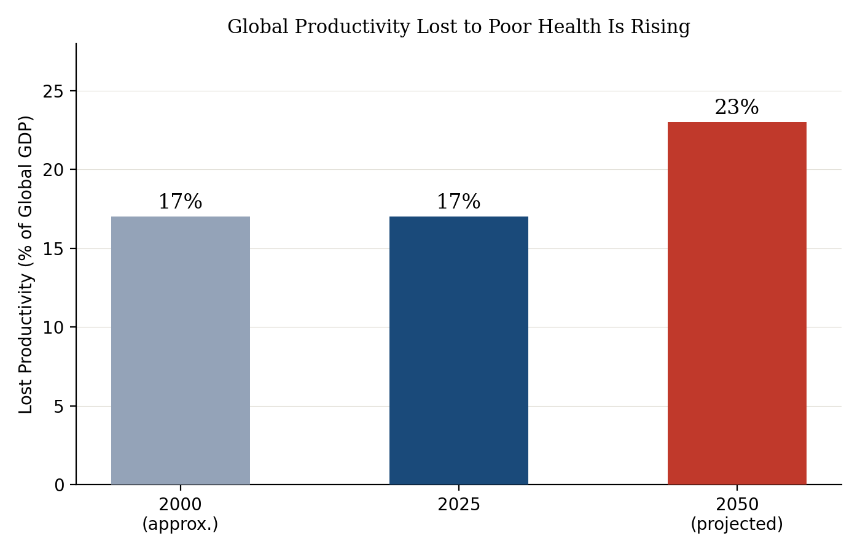

10.2 The Cost of Chronic Disease
The scale is genuinely staggering when priced out directly. In the United States alone, chronic disease is on pace to cost $47 trillion between 2024 and 2039 — $2.2 trillion annually in direct medical costs, and nearly $900 billion a year in lost productivity by 2039. Chronic conditions already drive $4.9 trillion of the US's annual healthcare bill. The same pattern repeats globally: earlier estimates placed the worldwide economic burden of non-communicable disease at roughly $47 trillion between 2010 and 2030 — a figure so large it is frequently mis-cited as US-specific, when it is in fact a global one, underscoring how consistently large this burden appears across independent studies using different methodologies.
“Chronic disease, and especially the accumulation of multiple chronic conditions, is the main driver of rising healthcare spending in the United States.” — Ken Thorpe, Chair, Partnership to Fight Chronic Disease

10.3 The Return on Prevention
This is where the economic case for prevention becomes concrete rather than aspirational. Better prevention, earlier intervention, and improved chronic-disease management — particularly around obesity — could prevent 150 million new chronic disease cases, save 13.5 million lives, and avoid $7 trillion in costs in the US alone between 2024 and 2039. Even modest behavioural change and improved care coordination could save $125 billion a year; more optimistic treatment-breakthrough scenarios could generate $465 billion in annual savings. Globally, scaling proven, cost-effective interventions could avert 35% of total disease burden by 2050, avoid 33 million premature deaths, and avert more than 461 million years of poor health annually — equivalent to roughly 18 additional healthy days per person, every year.

10.4 What AI Is Actually Worth, Economically
Separate from the workforce-retention case made in Section 5.3, AI carries a distinct, independently-estimated economic value. Multiple independent analyses — McKinsey, the National Bureau of Economic Research, and a Harvard-led Health Affairs Scholar study — converge on the same range: wider AI adoption could save the US healthcare system 5–10% of total spending, or roughly $200–360 billion annually, primarily through administrative automation rather than clinical breakthroughs. That convergence across independently-conducted studies is itself notable — this is not one optimistic projection, it is several methodologically distinct ones landing in the same place.
The scale of the opportunity is clearest against current administrative spending: US hospitals spent $687 billion on administration in 2023, against $346 billion on direct patient care — a roughly 2:1 ratio, with administrative costs now representing about 40% of total hospital expense. AI's $200–360 billion savings estimate would claw back a substantial share of that imbalance without touching clinical care itself.
[FIGURE 2 — AI Savings Potential vs. Current Administrative Spending, chart inserted below]
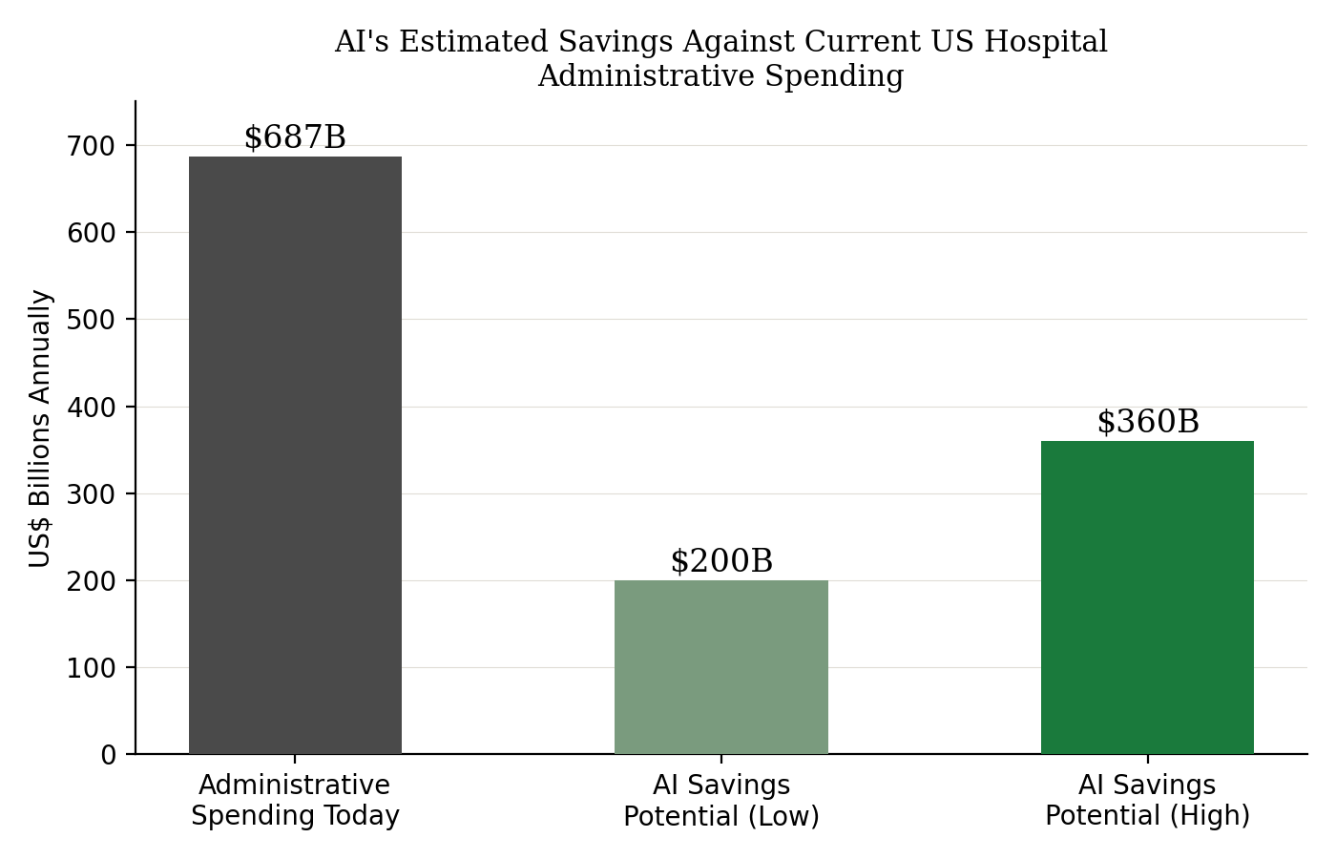

10.5 Spending Level Alone Does Not Buy Outcomes
The country data in Section 4 makes this concrete: the United States spends 18.0% of GDP on healthcare and achieves a 79-year life expectancy; Japan spends 11.5% and achieves roughly 84 years. The relationship between spending and outcome is not linear, and beyond a certain point additional spending appears to buy administrative complexity more reliably than additional years of life.
[FIGURE 3 — Health Spending vs. Life Expectancy, Six Countries, chart inserted below]
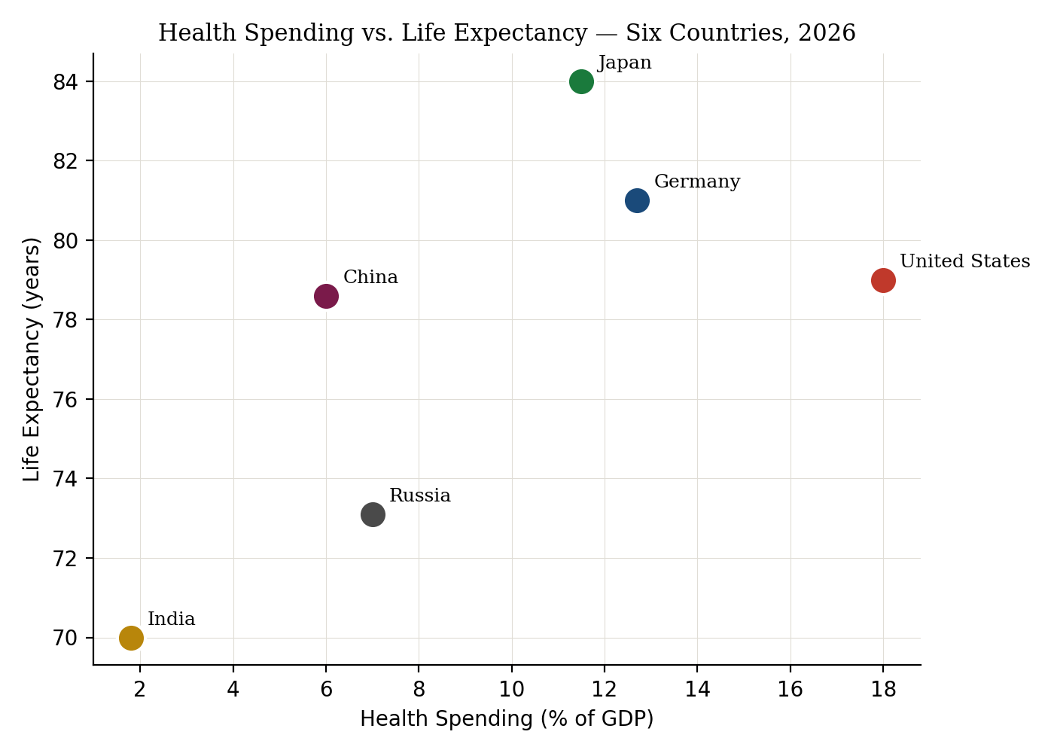

9. Healthcare 2035 — What's Already Real, and What Isn't Yet
Forward-looking sections in healthcare writing tend toward one of two failure modes: either they read as settled fact when they are genuinely speculative, or they hedge so heavily they say nothing useful. In keeping with NGE's own standard elsewhere — dated, falsifiable claims rather than vague forecasting — this section separates what is already real and scaling today from what remains genuinely uncertain, rather than presenting both with equal confidence.

11.1 Already Real and Scaling
AI-assisted diagnostics: already deployed at meaningful scale — this paper's own India section cites AI-assisted chest X-ray screening for TB in active use today, not a pilot.
Ambient clinical documentation: already the leading driver of the physician-burnout improvement documented in Section 5.1 — this is present-tense, not a 2035 prediction.
Wearable continuous monitoring: consumer-grade continuous glucose and cardiac monitoring is commercially available now; the open question is integration into formal care pathways, not the underlying technology.
Telemedicine and remote care: cited throughout this paper's country sections as an active reform tool in the US, China, Russia, Saudi Arabia, and Japan — fully mainstream, not emerging.

11.2 Genuinely Uncertain — Timeline and Scale Both Open
Widespread robotic surgery: real and growing in specific procedures, but a general-purpose expansion timeline is genuinely unclear — this varies enormously by procedure type and country, and treating it as one uniform trend overstates certainty.
Digital twins for individual patients: an active, well-funded research direction, but full clinical deployment at population scale by 2035 is an assumption, not a documented trajectory.
“Home hospitals” at scale: small, real pilot programmes exist; whether this becomes standard infrastructure depends more on reimbursement policy than on the underlying technology being ready.
Broad gene therapy access: real, approved therapies exist for specific rare conditions today; the honest constraint is cost and manufacturing scale, not scientific feasibility — closing that gap by 2035 is plausible but far from guaranteed.
The pattern across both lists is consistent with this paper's central argument: the technology is very rarely the actual constraint. Financing, workforce, policy, and institutional capacity are.

10. Conclusion
The exploration of healthcare systems around the world reveals a rich diversity, reflecting the distinct cultural, economic, and political landscape of each country. The 2026 data paints a sobering picture: fiscal pressure is intensifying, the workforce is buckling, and health ODA faces its steepest cuts on record.

Key Lessons From 2026 Data
- The United States spends 18.0% of GDP on healthcare by CMS's measure — nearly double the OECD average — yet ranks near the bottom on life expectancy and affordability among peer nations
- India spends 1.8% of GDP on health, less than half of Brazil (10%) and South Africa (9%), and below Russia (7%) and China (6%)
- The world faces a shortfall of 11 million health professionals by 2030, with 61% of healthcare workers currently reporting burnout
- Health ODA is projected to fall 29–46% from 2024 to 2026

The Path Forward
The most powerful argument for health AI is not cost savings or diagnostic speed — it is workforce survival. The coming decade demands that the question shift from whether AI can replace clinicians to how it can help keep them. In that reframed question lies a real path toward global equity, sustainable systems, and care that endures.
Human capital is the central lever of health outcomes. Policymakers must prioritise investment in human capital formation, strengthen healthcare capacity, and accelerate digital health development tailored to fiscal constraints.
Healthcare is both a moral imperative and an economic necessity. The human cost of inaction is measured in suffering and shortened lives. The economic cost is measured in lost productivity, household bankruptcy, and diminished national prosperity. The path forward requires political will, sustained investment, and a genuine commitment to serving the common man.
The greatest healthcare challenge of the 21st century is not merely discovering new medicines — it is ensuring that every person can benefit from them. Sustainable healthcare will depend on stronger institutions, healthier populations, empowered healthcare workers, and the responsible integration of artificial intelligence. Medicine must remain centred on people, because every healthcare system ultimately exists to serve the common man.

11. References

Reports and Official Publications
- Economics by Design (2026). Health Spending (% GDP) By Country, Health System Indicator: Place Based Value. EBD Place Based Value. Accessed 23 July 2026.
- OECD (2026). Restoring Public Finances: Executive Summary. OECD Publishing, Paris.
- OECD (2026). ODA projections for 2026 and the near-term. OECD Publishing, Paris.
- Devex (2026). Health ODA faces steepest cuts in 2026, OECD says. 22 June 2026.
- OECD iLibrary (2026). The latest 2026 ODA projections reveal aid for health is further at risk.
- Peterson-KFF Health System Tracker (2026). How does health spending in the U.S. compare to other countries?
- Centers for Medicare and Medicaid Services (2026). National Health Expenditure Accounts, 2024.

Academic and Peer-Reviewed
- Quality & Quantity (2026). Health equity in emerging markets: a comparative analysis of financing, human capital, and digital readiness. Springer. Published 2 July 2026.

Workforce and Burnout
- Rozen, M. (2026). Healthcare Burnout in 2026 — Why 61% of Healthcare Workers Are Still Burning Out, and Why AI Alone Cannot Fix It.
- Nurse.com (2026). 2026 Nurse Burnout Statistics: Rates, Causes, & Trends. Nurse Salary and Work-Life Report.
- Healthcare Dive (2026). Burnout is increasing, while employee confidence is at a record low. 20 May 2026.
- HealthLeaders Media (2026). The Majority of Nurses Report Feeling Emotionally Exhausted at Work. 23 March 2026.

Country-Specific
- Forbes India (2026). India's health, education spending lags BRICS peers despite economic growth. 30 January 2026.
- BRICS Connect (2026). India's spending on health and education trails BRICS peers, despite economic growth. 1 February 2026.

Health Spending Data
- Wikiwand (2026). Health spending as percent of GDP by country. Data from OECD Health Statistics.
- Strive Edge IAS (2026). Public Health Financing — India.

Global Health Financing
- Australian Global Health Alliance (2026). Global Health in the 2026-27 Federal Budget Analysis. 22 May 2026.
- CNBC Africa (2026). Africa's Health Financing Paradox: Plenty of Capital, Too Little Investment. 14 May 2026.

World Health Organization
- WHO (2026). Health workforce. who.int/health-topics/health-workforce.

Health Economics (Section 8 Sources)
- Partnership to Fight Chronic Disease (2025). New Report: Chronic Disease Could Cost the U.S. $47 Trillion Over Next 15 Years. December 2025.
- Centers for Disease Control and Prevention (2026). Fast Facts: Health and Economic Costs of Chronic Conditions. cdc.gov/chronic-disease.
- Bloom, D. et al. (2012, as cited 2026). The Global Economic Burden of Non-communicable Diseases, 2010–2030. World Economic Forum / Harvard School of Public Health.
- HealthManagement.org (2026). Health Investment as an Engine of Growth. 4 March 2026.
- McKinsey & Company (2026), as cited in Makebot.ai: AI Could Save the Healthcare Industry $360 Billion Annually. 18 March 2026.
- National Bureau of Economic Research (2023, as cited 2026). The Potential Impact of Artificial Intelligence on Healthcare Spending.
- Health Affairs Scholar (2026), as cited in Paubox: Can AI Make Healthcare Cheaper, or Will Businesses Keep the Savings? Includes CMS National Health Expenditure Data, 2024.
- Sully.ai (2026). Cut Healthcare Administrative Costs with Workflow Automation. 27 May 2026 — US hospital administrative spending data, 2023.

About This Paper
Compiled with the assistance of AI tools for data synthesis and drafting, and rigorously reviewed and verified by Pawan Bhatia against primary sources. This is the ninth white paper published by NextGen Economics, following the editorial standards set out in NGE's public methodology — every claim sourced and dated, and corrected in public where a figure did not hold up under review.
Pawan Bhatia is the founder of NextGen Economics, an independent research platform publishing long-horizon analysis on capital, technology, and the forces shaping the next decade of wealth creation.
This paper is part of NGE's white paper series alongside prior work on AI alignment, equity markets, and technology infrastructure — available in full at nextgeneconomics.com.
© 2026 NextGen Economics · Pawan Bhatia · Bangalore, India · nextgeneconomics.com

List of Acronyms
Acronym | Definition
AI | Artificial Intelligence
AMA | American Medical Association
APRN | Advanced Practice Registered Nurse
BRICS | Brazil, Russia, India, China, South Africa
DAC | Development Assistance Committee
EM7 | China, India, Russia, Brazil, Indonesia, Mexico, Turkey
EU-27 | European Union (27 member states)
FY | Fiscal Year
GDP | Gross Domestic Product
HCI | Human Capital Index
LIC | Low-Income Country
LPN/LVN | Licensed Practical Nurse / Licensed Vocational Nurse
MIST | Mexico, Indonesia, South Korea, Turkey
NCD | Non-Communicable Disease
NHE | National Health Expenditure (US, CMS measure)
ODA | Official Development Assistance
OECD | Organisation for Economic Co-operation and Development
OLS | Ordinary Least Squares
PPR | Pandemic Preparedness, Prevention, and Response
RN | Registered Nurse
TB | Tuberculosis
UN | United Nations
WHO | World Health Organization

